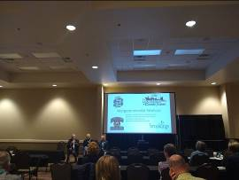The South Dakota Planners Association hosted the annual conference bringing together planners, administrators, planning commissioners, and consultants for an opportunity to learn from each other in different areas of the state on October 16-17, 2019. Barry Dunn, President of South Dakota State University, Keith Corbett, Mayor of Brookings, and Mike Bartley, Brookings County Commission Chair presented some cooperative efforts across each governmental entity are providing value to the public. The presentation began with an explanation of the quarterly strategic meetings that are held with the City, County, and School leaders. The theme of the presentation dealt with open and honest communication and relationships among key stakeholders. For example, SDSU goes to the City as well as the County with plans and questions for projects. The Brookings Area Transportation Authority SafeRides program is one example of the City, County, and Schools working together financially to fund a needed service to students and area residents.
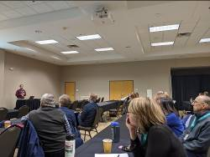
The keynote address was followed by two breakout sessions on planner and developer relations as well as an interactive group discussion on growth management strategies. The growth management session began with a presentation on the Density Zoning Ordinance in Minnehaha County and focused on providing county planners with strategies to keep it rural in their jurisdiction while managing housing density as well as economic development.

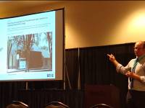Scott Harmstead, SRF Consulting Group, provided a review of a few recent land development regulation projects SRF worked on around the region. Scott explained the process currently being developed for the City of Fargo, North Dakota in coordination with Lisa Wise Consulting, Inc. using a more in-depth analysis of the existing land development codes. The presentation ended with a group activity identifying successes in development regulations, challenges in the regulations, and how to move forward in addressing some of these issues. SDPA members and conference attendees are grateful for Scott travelling from Bismarck, North Dakota for his presentation as well as attendance at the 2019 SDPA Annual Conference.

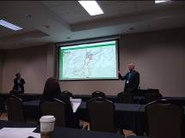The first general session was followed by two more breakout sessions on creating a Community Improvement District and regulating Accessory Dwelling Units on the west side of the state. The Powder House Pass Community Improvement District is a 1,000 acre subdivision plat for a future development community in Lawrence County. The advantage of a CID Plan is that it enables us to “think like a community, not just what’s going to be in front of my house”, Kevin Smith, AICP.
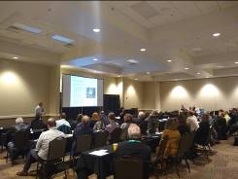
Jeremiah Bergstrom, South Dakota State University Instructor of Landscape Architecture, presented on a history of watershed management and several case studies of community-based water resources management. Jeremiah explained the need to deal with stormwater runoff at the source for effective management strategies and allow the landscape to function as it was designed to do prior to development practices. He discussed that we need to know our watershed partners as well as what’s connected versus disconnected water infrastructure. The presentation included a discussion about precipitation patterns in South Dakota, which tended to be wetter in the past year. The best way to take on watershed issues is to find the person who has the respect to listen and be listened to by the larger group. Jeremiah was very thoughtful in his approach to educating and engaging the conference attendees about stormwater management best practices in various climate contexts.

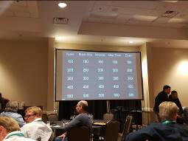One of the major highlights of the SDPA Business Meeting was the decision to forgo the annual fall conference next year in exchange for a pending agreement with the North Dakota Planning Association and Western Planner Conference that will be held August 26-28, 2020, Mandan-Bismark, North Dakota. Another related decision was to offer up to $5,000 (up to $150 each application) in conference support to attend the Western Planner Conference next year. In lieu of not hosting a fall conference next year, SDPA will host a special one-day training workshop in Oacoma, SD during the spring months to be built by the membership. The group finished the meeting with a discussion on such legislative items as the Conditional Use Permit kickback for CAFO development, Wind Energy regulations, and Road Maintenance jurisdictional issues on old platted right-of-ways. The SDPA board will be working on a strategy for future conferences as well as developing an application process for conference support and AICP-related expenses. The whole group finished off day 1 of the conference with dinner, drinks, and a good ole’ fashioned friendly game of Planners’ Jeopardy filled with all sorts of state history and planning-related questions!
Photo taken by Scott Harmstead

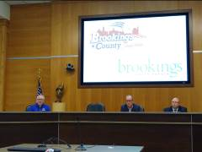The second day of the conference began with the popular legal duo of Jack Hieb and Zach Peterson from Watertown, South Dakota who have been involved in many planning and zoning related cases over the course of their respective law careers. Jack started off the discussion with a reminder that challenging the decision doesn’t work, so the opponents are beginning to challenge the decisionmaker or process that involves the conference attendees who administer their local zoning regulations. The focus of the presentation was on the difference between adjudicating and legislating procedures. Jack and Zach dedicated much of their time towards providing discussion answers on meeting procedures, ex parte communication issues, and recent changes in state law.
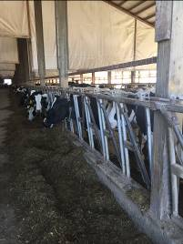
The second day finished off with two separate group tours: rural and urban. The urban tour group visited a few key privately-funded facilities such as the Children’s Museum of South Dakota, Dana J. Dykhouse football stadium, Sanford-Jackrabbit indoor training facility, and the Dakota Nature Park among other notable sites along the tour route in the City of Brookings. The rural tour group visited a dairy concentrated animal feeding operation and a wind tower farm in rural Brookings County.
Photo, above, taken by Kevin Hoekman at Dairy Farm
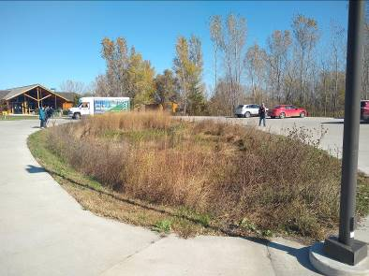
In 2020, SDPA will be encouraging members to consider attending the 2020 Western Planner & North Dakota Planning Association Conference in Bismarck/Mandan, North Dakota from August 26-28, 2020. The theme of the conference will be Serving as a Bridge. How can planners and design professionals create bridges between important, but sometimes conflicting, values in our communities? Historic heritage and dynamic change; Public good and private development; Urban and rural; The range of values and visions of citizens and stakeholders in our communities.
Stormwater Rain Garden at the Dakota Nature Park
Photo taken by David Heinold

David Heinold, AICP
SDPA Vice President

